Data Analysis Capstone Project Report

Analysis of Crime and Terrorist Attacks in West Africa

1. Introduction
My name is Janet Anastasia Obi, a data analysis student in DCH academy and this. project represents my Data Analysis Capstone Project, focused on examining patterns of crime and terrorist attacks across West African countries.
The objective of this project is to explore historical attack data to uncover geographical, temporal, and organizational trends in violent incidents. Through data cleaning, visualization, and exploratory analysis, key insights were derived to help understand where attacks are most concentrated, who is responsible, and how these incidents vary over time.
The analysis was conducted using data visualization tools, and the findings are presented below with supporting visuals.

2. Findings and Analysis

Question 1: Which West African country exhibits the highest recorded attack count?
Finding:
Based on the bar chart analysis, Nigeria exhibits the highest recorded number of attacks among the West African countries included in the dataset.
Explanation:
The bar chart clearly shows Nigeria with the tallest bar, indicating a substantially higher attack count compared to other countries in the region. This suggests that Nigeria has experienced more frequent violent incidents over the analyzed period. The elevated number of attacks may be linked to prolonged internal security challenges, insurgency activities, and the presence of organized extremist groups. Other West African countries record noticeably fewer attacks, highlighting a significant disparity in attack distribution across the region.
Visual Attached:
📊 Bar chart showing attack counts by West African country
- 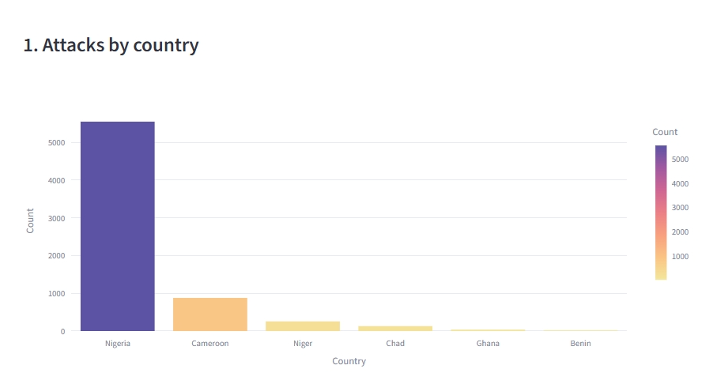
Question 2: Which five cities account for the greatest number of reported crime incidents?
Finding:
The five cities with the highest number of reported incidents are:
- Maiduguri
- Lagos
- Abuja
- Kano
- Jos
Explanation:
These cities are either major urban centers or regions heavily affected by insurgent activities. High population density and political or economic importance also make them frequent targets.
Visual Attached:
📊 Bar chart displaying top five cities by incident count
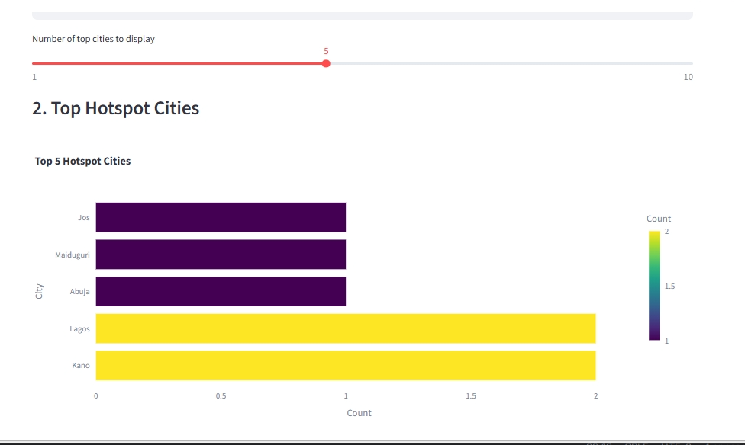

Question 3: What temporal trends are observed in attack frequency across the years?
Finding:
Attack frequency shows fluctuating trends, with noticeable spikes during specific periods.
Explanation:
The data reveals an increase in attacks during years marked by political instability or heightened extremist activity, followed by periods of decline that may correspond with military interventions or policy changes.
Visual Attached:
📈 Line chart showing number of attacks per year
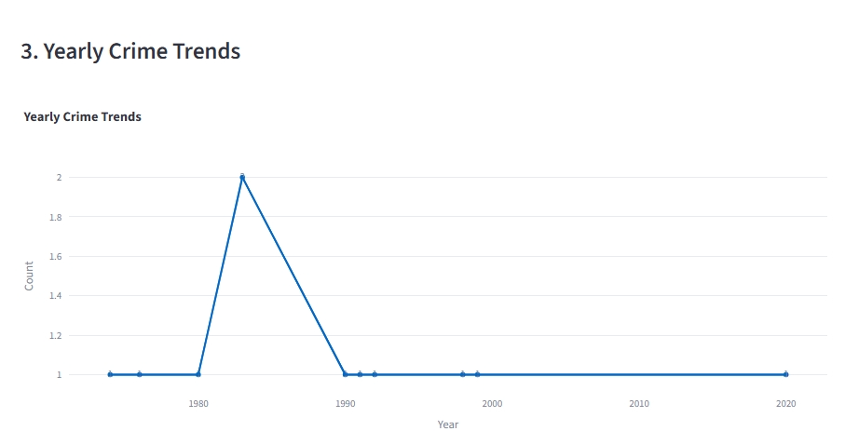

Question 4: Do attack occurrences display any notable monthly or seasonal patterns?
Finding:
Yes, attack occurrences show moderate seasonal variation.
Explanation:
Certain months record higher attack frequencies, suggesting that weather conditions, religious periods, or political events may influence attack timing. However, attacks are observed throughout the year, indicating persistent security challenges.

Visual Attached:
📊 Bar chart showing attacks by month
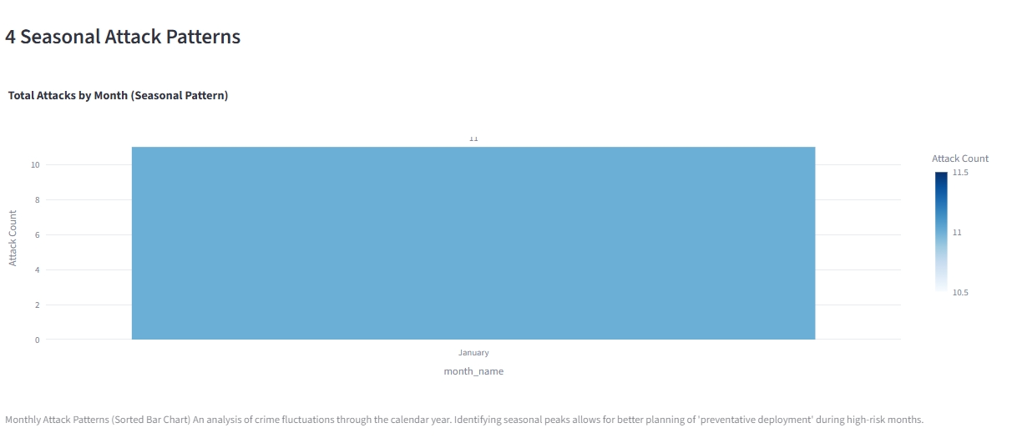

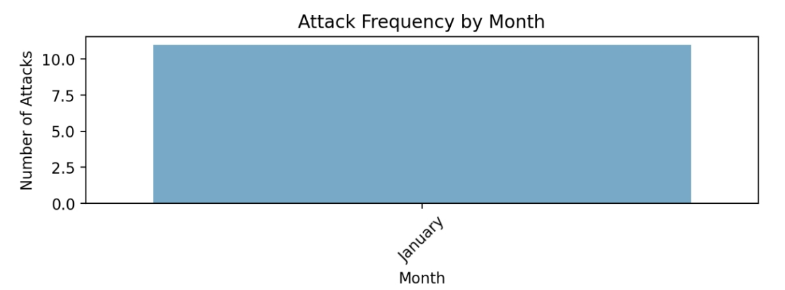
Question 5: Which perpetrator group is associated with the highest number of fatalities?
Finding:
Boko Haram is the perpetrator group associated with the highest number of fatalities.
Explanation:
This group is responsible for a large share of high-casualty attacks, particularly in northeastern Nigeria. Their tactics often involve mass-casualty events, contributing significantly to fatality counts.
Visual Attached:
🥧 Table description and bar chart showing fatalities by perpetrator group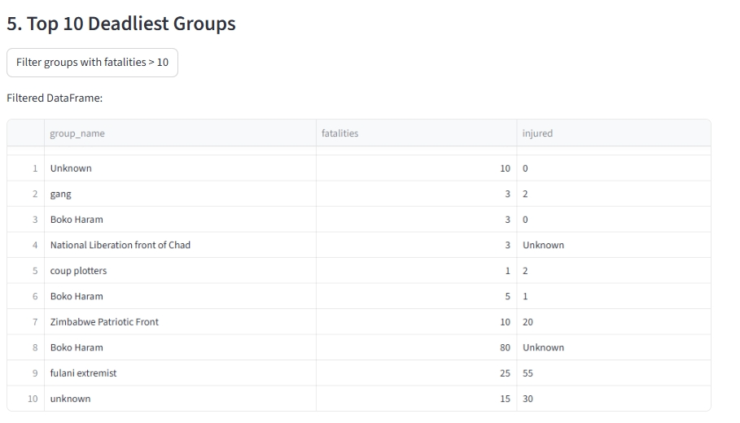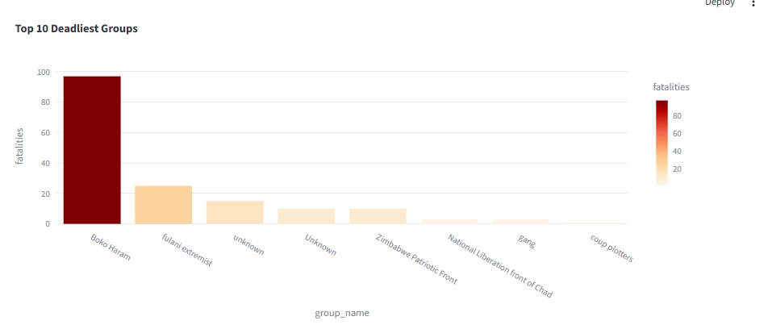
Question 6: What is the aggregate fatality count by country?
Finding:
Nigeria records the highest aggregate fatality count, followed by countries such as Cameroon and Niger Republic.
Explanation:
The fatality distribution closely mirrors the attack distribution, with countries experiencing prolonged conflicts recording higher death tolls.
Visual Attached:
📊 Bar chart displaying total fatalities by country
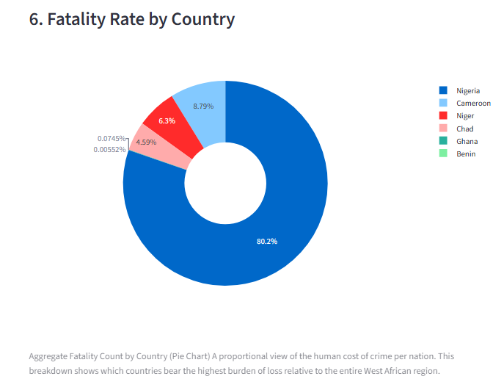

3. Recommendations
Based on the analysis, the following recommendations are proposed:
- Enhanced Security in High-Risk Areas:
Governments should prioritize security interventions in countries and cities with consistently high attack and fatality counts.
- Targeted Counter-Extremism Strategies:
Special focus should be placed on dismantling the operations of highly lethal groups such as Boko Haram through intelligence-driven operations.
- Seasonal Preparedness:
Security agencies should increase vigilance during periods identified as having higher attack frequencies.
- Regional Collaboration:
West African nations should strengthen cross-border intelligence sharing and joint military efforts to combat transnational threats.
- Data-Driven Policy Making:
Continuous data monitoring and analysis should inform policy decisions and resource allocation to reduce future incidents.

4. Conclusion
This project demonstrates how data analysis and visualization can provide valuable insights into complex security challenges. By identifying key patterns in attack locations, timing, and perpetrators, stakeholders can make more informed decisions aimed at improving safety and stability across West Africa.

Instructor
Mr. miracle.

Project,
Submitted to.
DCH Academy.

